Dear families of BBMS students,

Your student(s) are about to start the genetics unit in science class. This unit is exciting and fun for students; however, mastering some of the genetics problems can be difficult. To help your students accomplish this, they will complete a series of at-home, online assignments. This project consists of activities, animations, and practice problems, which reinforce the material they will learn in class. This project will take two weeks and its components will be factored into both homework and project grades.
WEBSITE: Students will visit the following website:http://bbmsgenetics.weebly.com/ (this link is on the wiki under “homework”). This website contains directions and links for the assignments they will complete. Mr. Janelli and I expect that students will follow the timeline included below, visit the website daily, and complete the assigned activities.
The genetics webpage has two sub-pages you can click on, one called “Mendel’s Work” and one called “Punnet Squares”. The first page correlates more with 3.1 from the textbook, and the second page correlates more with 3.2.

INSTRUCTIONS AND EVIDENCE: On each of these sub-pages are instructions telling the students what links to visit first, and how to show evidence that they visited them. This evidence is usually shown by answering questions regarding the content on that particular page. They will upload this evidence by clicking one of the ‘Upload’ links at the bottom of the page.
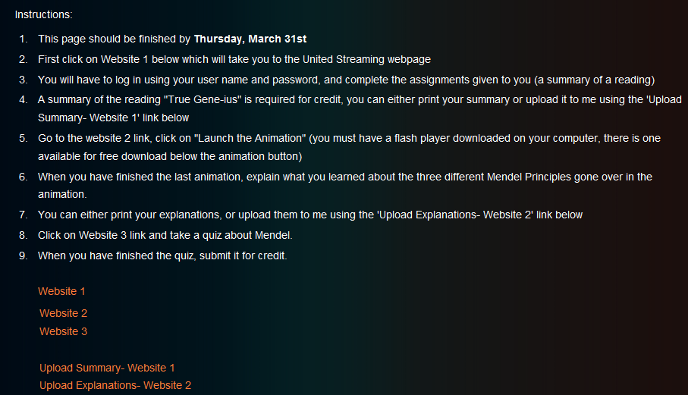
Click to upload evidence
Links to websites
The evidence is very important because this is the only way to assess the student’s understanding of the material, and assess that they have gone through the websites thoroughly.
UNITED STREAMING: The very first link your student will be visiting under the “Mendel’s Work”page will require an ID and login. This was given to them in class. If they have forgotten or lost it, please email me.
FLASH: Some of the animations they are assigned to see require one of two flash players: the latest version of Shockwave and Flash player version 10. Here are links where you can download them if you do not already have them. They are free and safe.
- http://get.adobe.com/flashplayer/
- http://get.adobe.com/shockwave/
This project should enrich their understanding and appreciation for genetics. Please help your students succeed by supporting their completion of this project.
TIMELINE: A chart showing the due dates is below. Notice that there are only two mandatory due dates when evidence is due, however, I have outlined a recommended time-line for your students to follow. Following this time-line will allow for them to never have more than one assignment in a night. The first three pieces of evidence are due on April 4th. The last five pieces of evidence are due on April 11th.
Please sign the bottom of this sheet agreeing that you will support your child in completing this project. If your child will not have daily or bi-daily access to a computer or the internet, please indicate this on the sheet and we will arrange for them to have access in school. None of the assignments should take your student more than an hour to complete.
Thank you so much for your support in advance!
Sincerely,
Erica Hart, Contact me with questions or concerns: (ericamee7@gmail.com)
Page/  Concept | Website | Evidence form | Recommended Completion/ Mandatory Completion bolded
Mendel’s Work | http://my.discoveryeducation.com/ - website 1 | Upload summary and questions on weebly | 3/29-3/30
Mendel’s Work | http://www.mendel-museum.com/eng/1online/experiment.htm - website 2 | Upload on weebly | 3/30-3/31
Mendel’s Work | http://anthro.palomar.edu/mendel/quizzes/mendqui1.htm website 3 | Results will be automatically emailed to me | 3/31-4/3
Mendel’s Work | Whole ‘Mendel’s Work’ page Due! | ALL above | 4/4
Punnet Squares | http://www.youtube.com/watch?v=SfkxcxBg4fM&p=E306A23FA4626910 and http://www.youtube.com/watch?v=fbYkjUv0QPQ&p=E306A23FA4626910 website 4 and 5 | Upload evidence on weebly | 4/4-4/5
Punnet Squares | http://www.siskiyous.edu/class/bio1/genetics/monohybrid_v2.html website 6 | Upload evidence on weebly | 4/5-4/6
Punnet Squares | http://wps.prenhall.com/esm_freeman_biosci_1/7/1948/498846.cw/index.html website 7 | Upload evidence on weebly | 4/6-4/7
Punnet Squares | http://biology.clc.uc.edu/courses/bio105/geneprob.htm website 8 | Upload evidence on weebly | 4/7-4/8
Punnet Squares | http://www.k-state.edu/biology/pob/genetics/mono.htm website 9 | Upload evidence on weebly | 4/8-4/11
Punnet Square | Whole ‘Punnet Square’ page due! | ALL above | 4/11

I agree that I will support my son or daughter,_________________________________(students name), in following the timeline for this project in order to help them better comprehend the material we are covering in class. I understand this requires their need for at least one hour of computer/internet time every other day for the duration of the project (2 weeks).

Your name: __________________________________________________________________

Signature: ___________________________________________________________________
Concerns or comments:

